

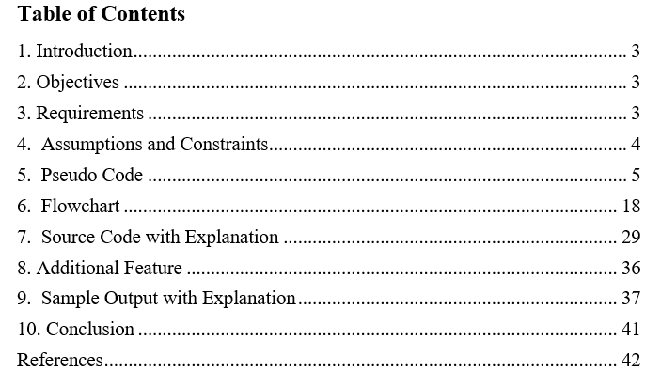

# 1. Introduction

Dennis Ritchie created C programming language at Bell Labs in the early 1970s, and it is a programming language that can be used for various purposes (Brian W.Kernighan, 2002). It offers useful features like memory manipulation, bitwise operations, and structured programming. Programs written in C are compiled into machine language before being executed. C is a popular language used in the software industry due to its versatility and power (Brian W.Kernighan, 2002).

We need to create a voting system that allows voters to select their preferred candidates, with the candidate receiving the highest number of votes being declared the winner, regardless of the percentage of total votes they receive or if they have a majority. Our goal is to develop a voting system using the C language that enables voters to choose their preferred candidates

# 2. Objectives

The objectives of the voting system are listed in the pointes below:

* To develop a system for voting which is efficient and impartial, enabling voters to cast their votes without any restrictions or bias.
* To ensure the automatic counting of votes, which will result in the election of the candidate with the highest number of votes.
* To provide a platform that allows for the registration of eligible candidates and the collection of voter details.
* To enable voters to securely cast their votes using unique login credentials.

# 3. Requirements

The implementation of a voting system necessitates the fulfillment of some prerequisites which are mentioned in the points below:

1. The system must be capable of scheduling the election, specifying the date and the constituency where it will be held.
2. The system should allow for the registration of candidates by collecting their name, political party affiliation, and the constituency they are competing in.
3. Only the administrator should have the ability to add, modify, or delete candidate information.
4. The system must have a feature to register eligible voters, including their name, date of birth, address, and password.
5. The system must verify a voter's eligibility based on their age, which should be over 18.
6. The system must enable registered voters to modify their information and update their password.
7. The system should have a search feature to allow users to search for a voter's details using their unique number.

# 4. Assumptions and Constraints

* The system assumes that voters will only vote once and will not attempt to vote multiple time.
* The system assumes that all dates entered by the users will be in the format of the Bikram Sambat (BS) calendar.
* The variables have been named in a clear and meaningful way to indicate their purpose.
* The system assumes that only eligible voters are allowed to cast their votes, and any attempts to vote by ineligible voters will be rejected.
* Tie goes to the candidate who received the most votes first.

# 5. Pseudo Code

Pseudo-code is a method of explaining a computer program using ordinary language instead of the precise syntax and keywords of a programming language. It provides a rough sketch that can be effortlessly translated into real programming statements. Pseudo-code is not intended to be compiled or executed, and it does not have strict formatting or syntax rules. Its purpose is to help bridge the gap between an informal description of a programming task and the final executable program (Anthi Karatrantou, 2008).

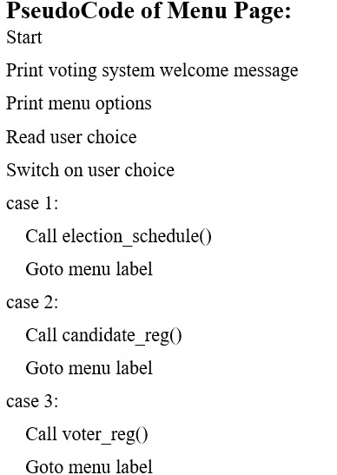

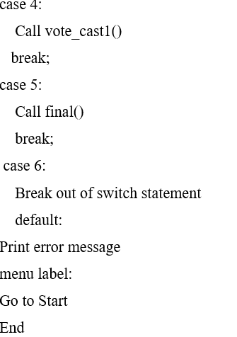

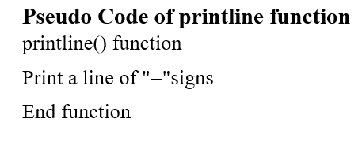

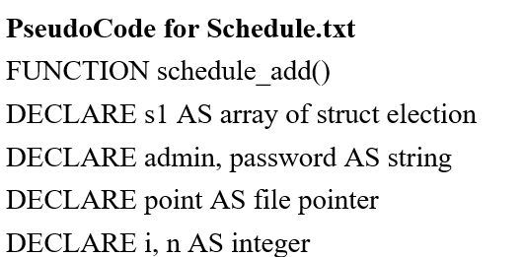

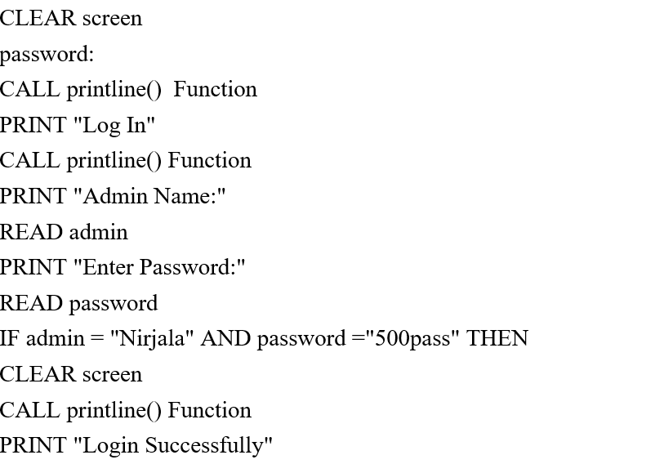

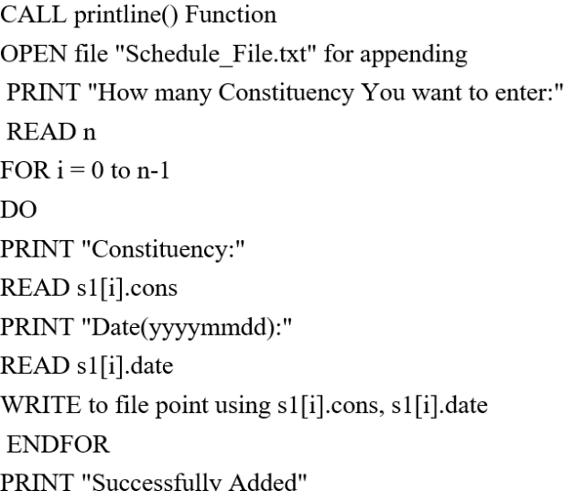

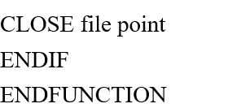

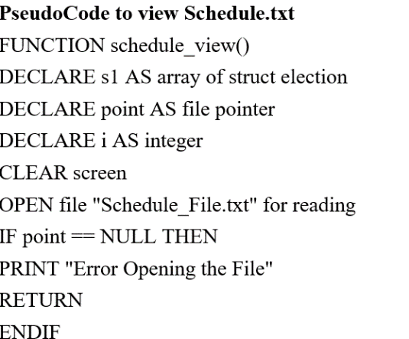

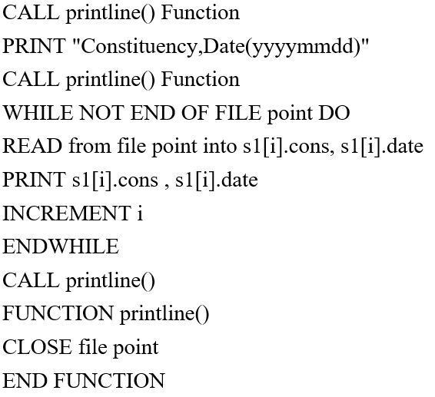

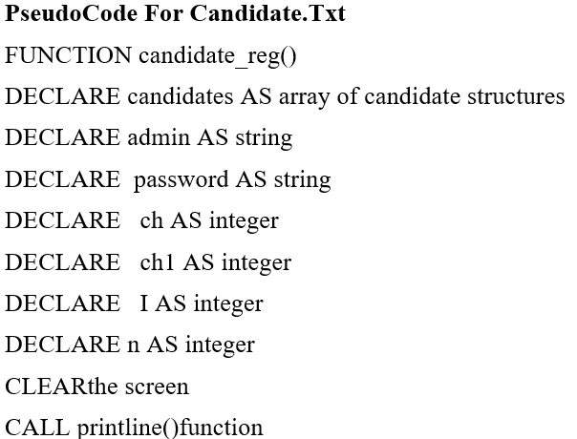

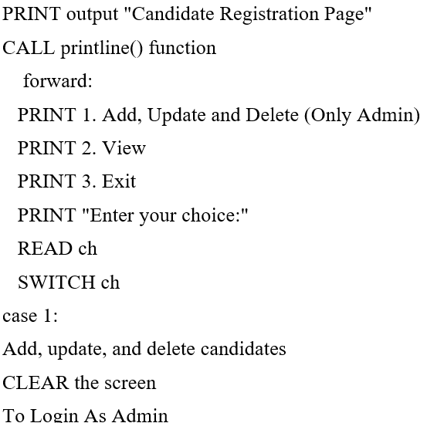

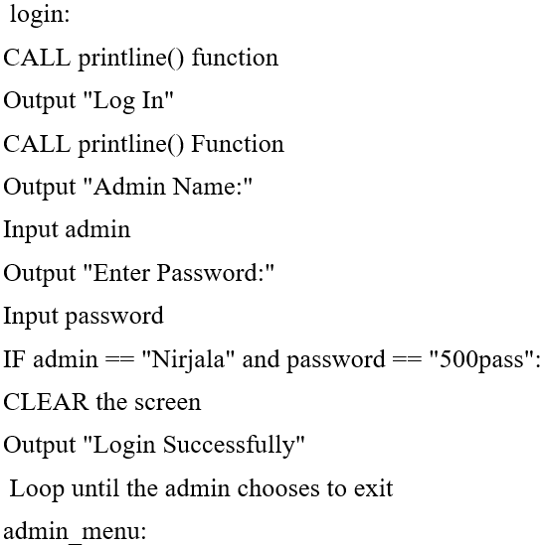

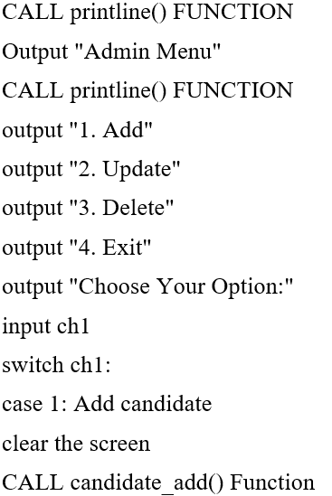

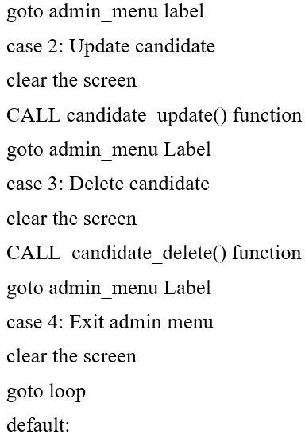

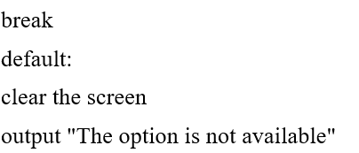

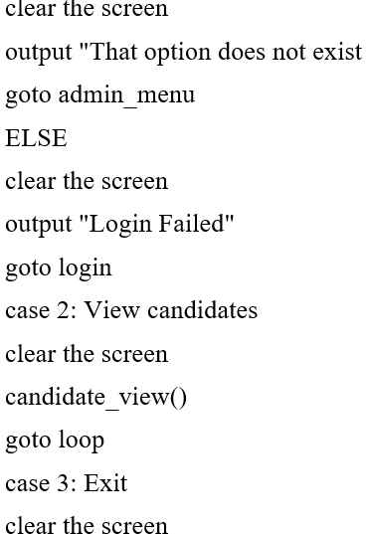



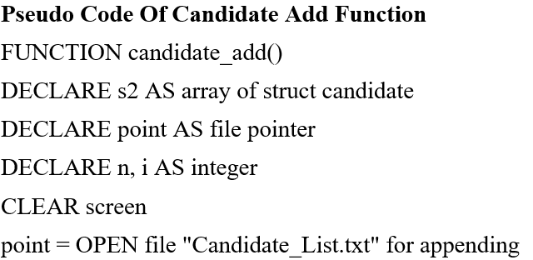

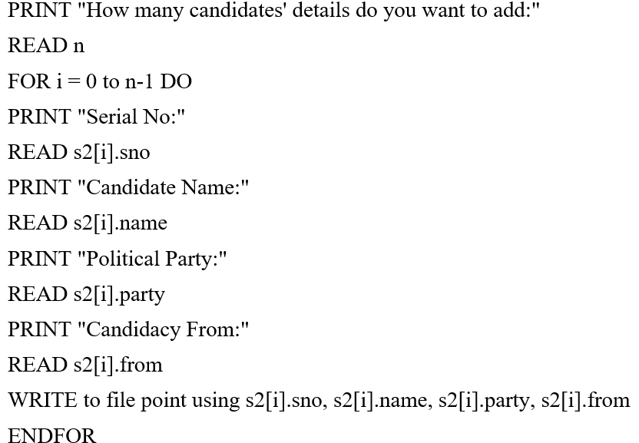

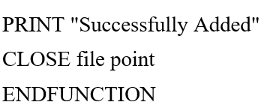

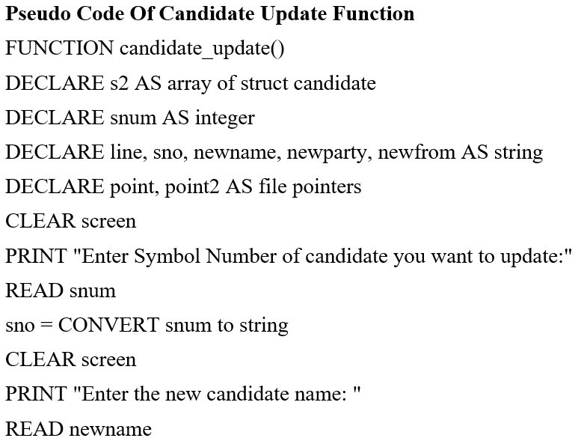

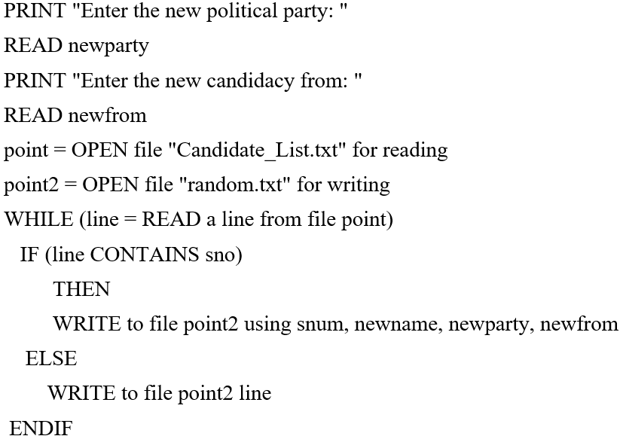

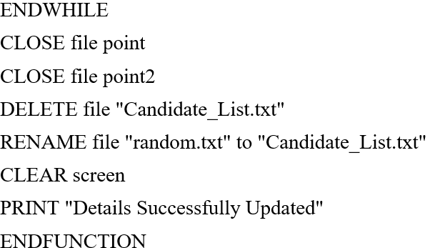

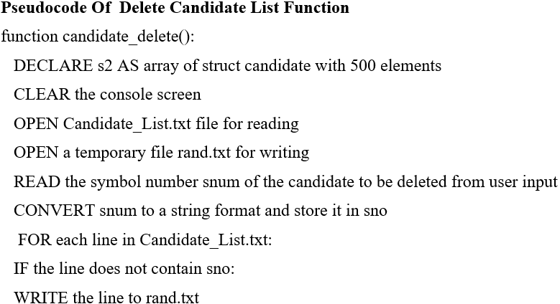

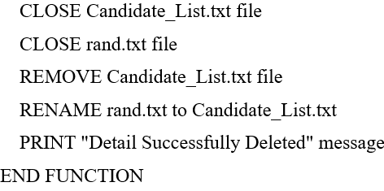

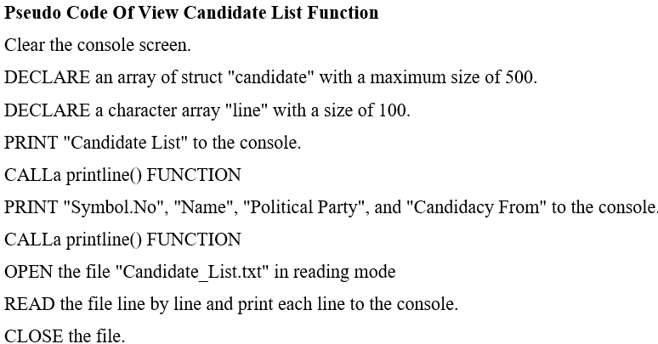



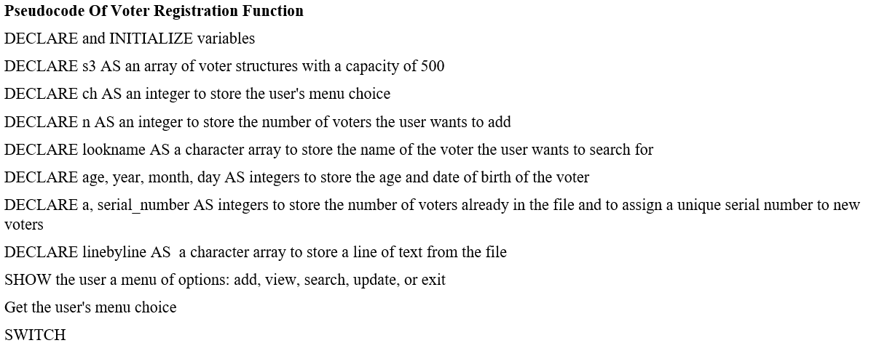

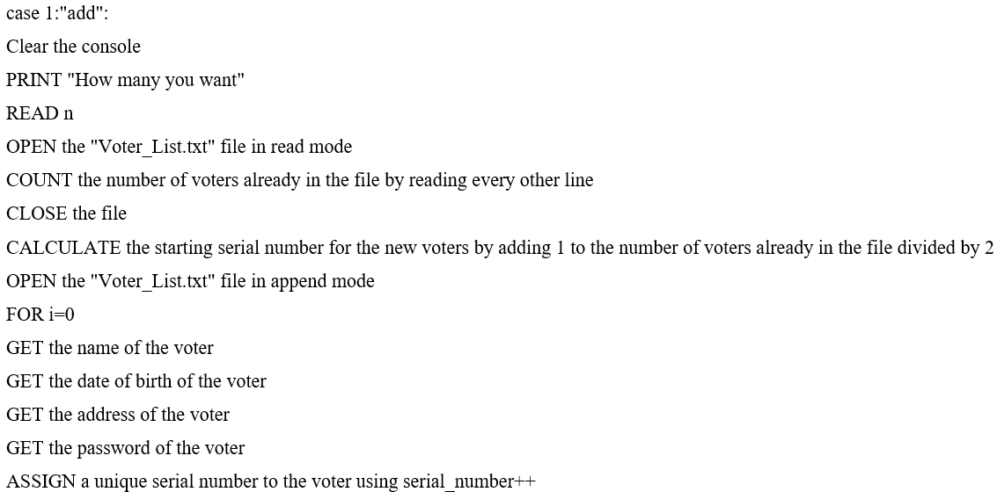

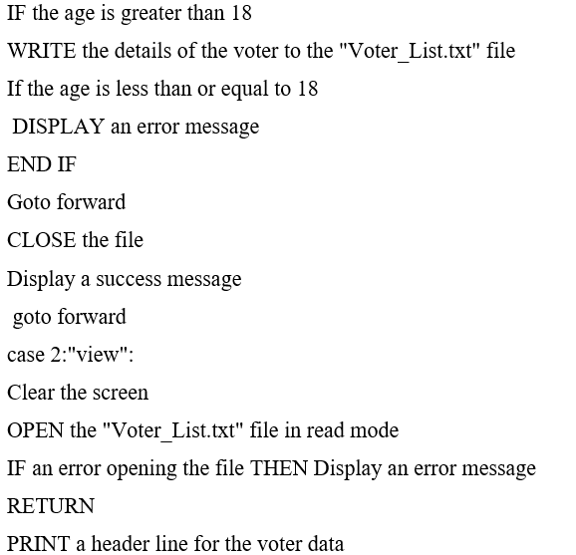

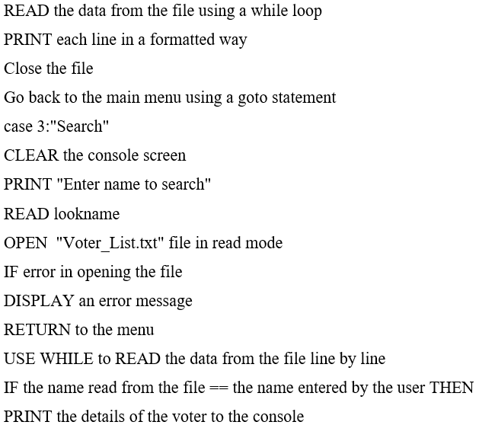

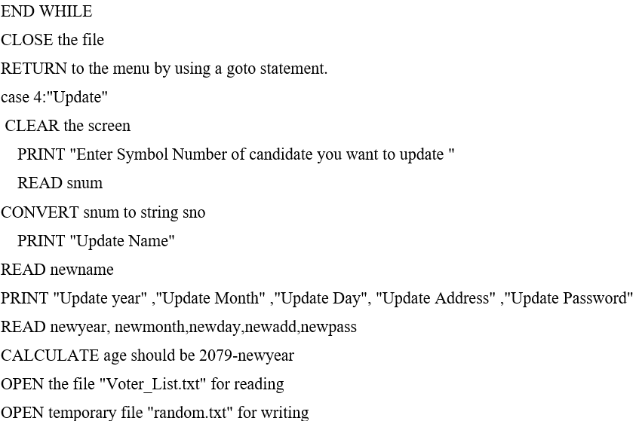

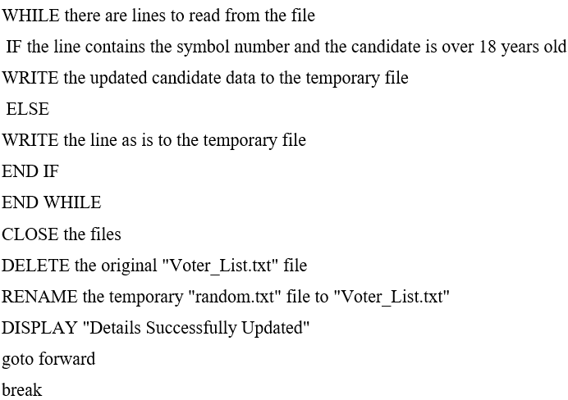

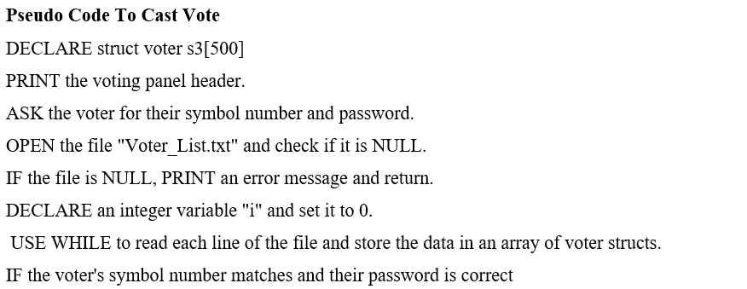

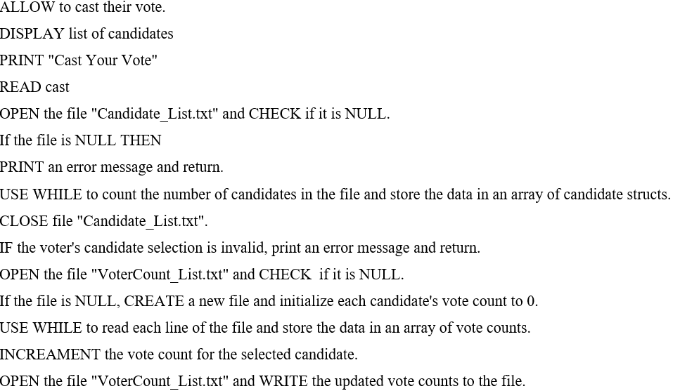



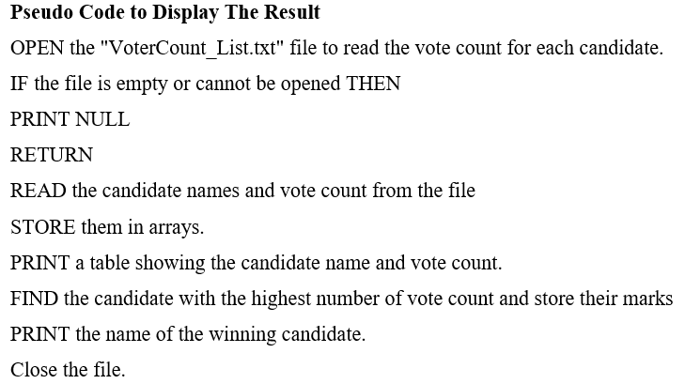

# 6. Flowchart

A flowchart is a graphical illustration of a process or program that employs symbols and arrows. It is advantageous for comprehending relationships, collecting data, making decisions, assessing performance, depicting structure, and monitoring flow (Technopedia, 2011). Symbols such as ovals, rectangles, diamonds, arrow lines, and parallelograms are used to represent different elements. Software program named Visio is used to generate the entire flowchart of this system.

**Flowchart of Menu Page**

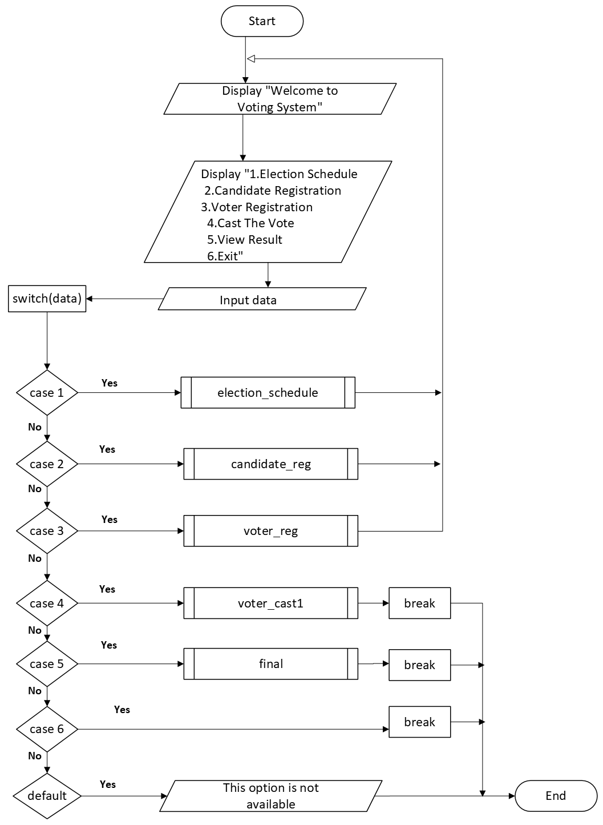

**Flowchart of election_schedule**

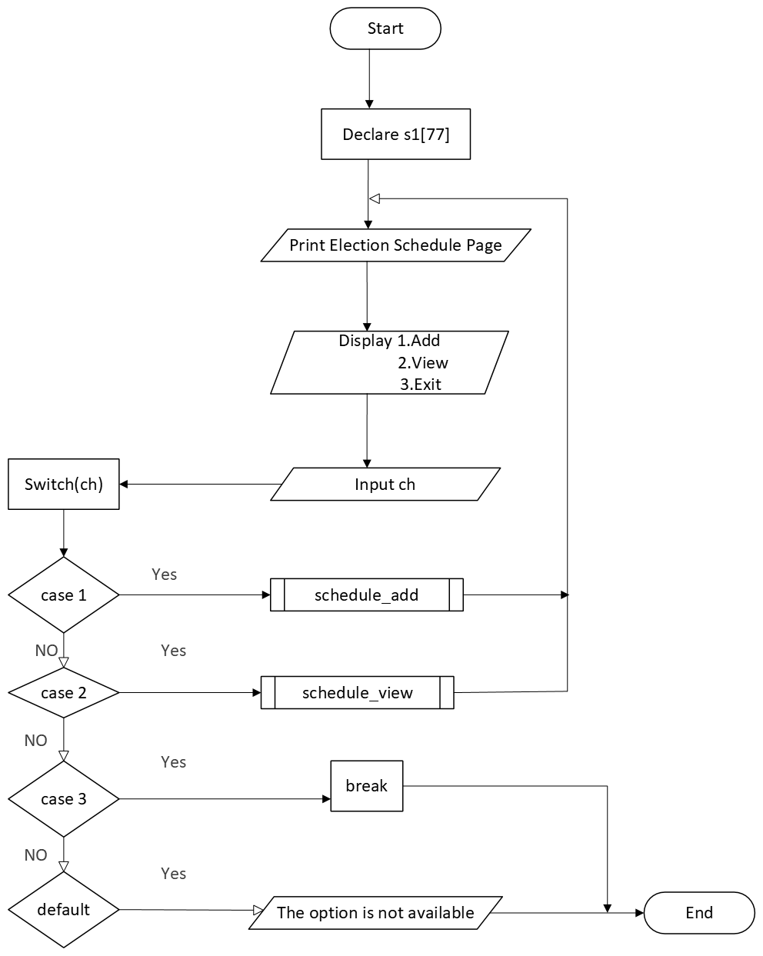

**Flowchart of schedule_add**

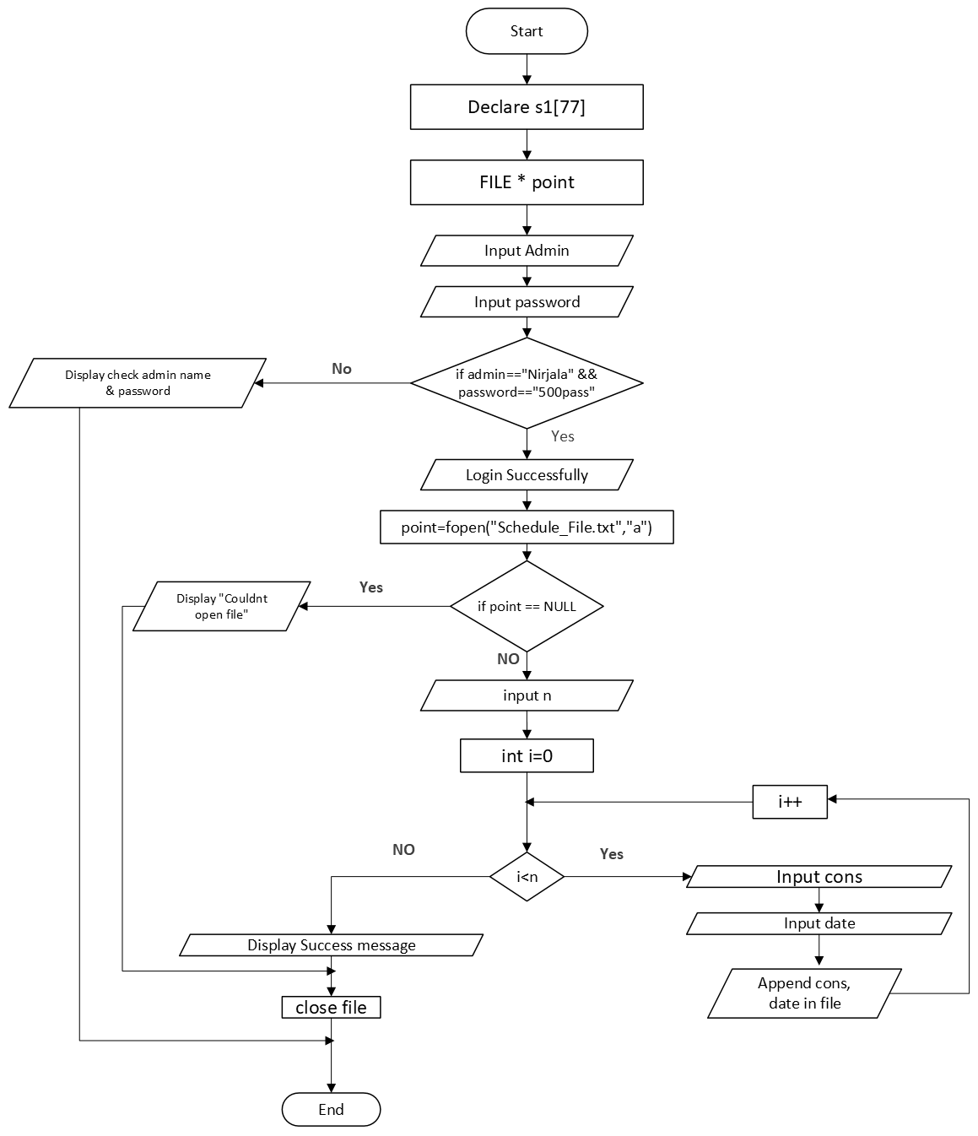

**Flowchart of schedule_view**

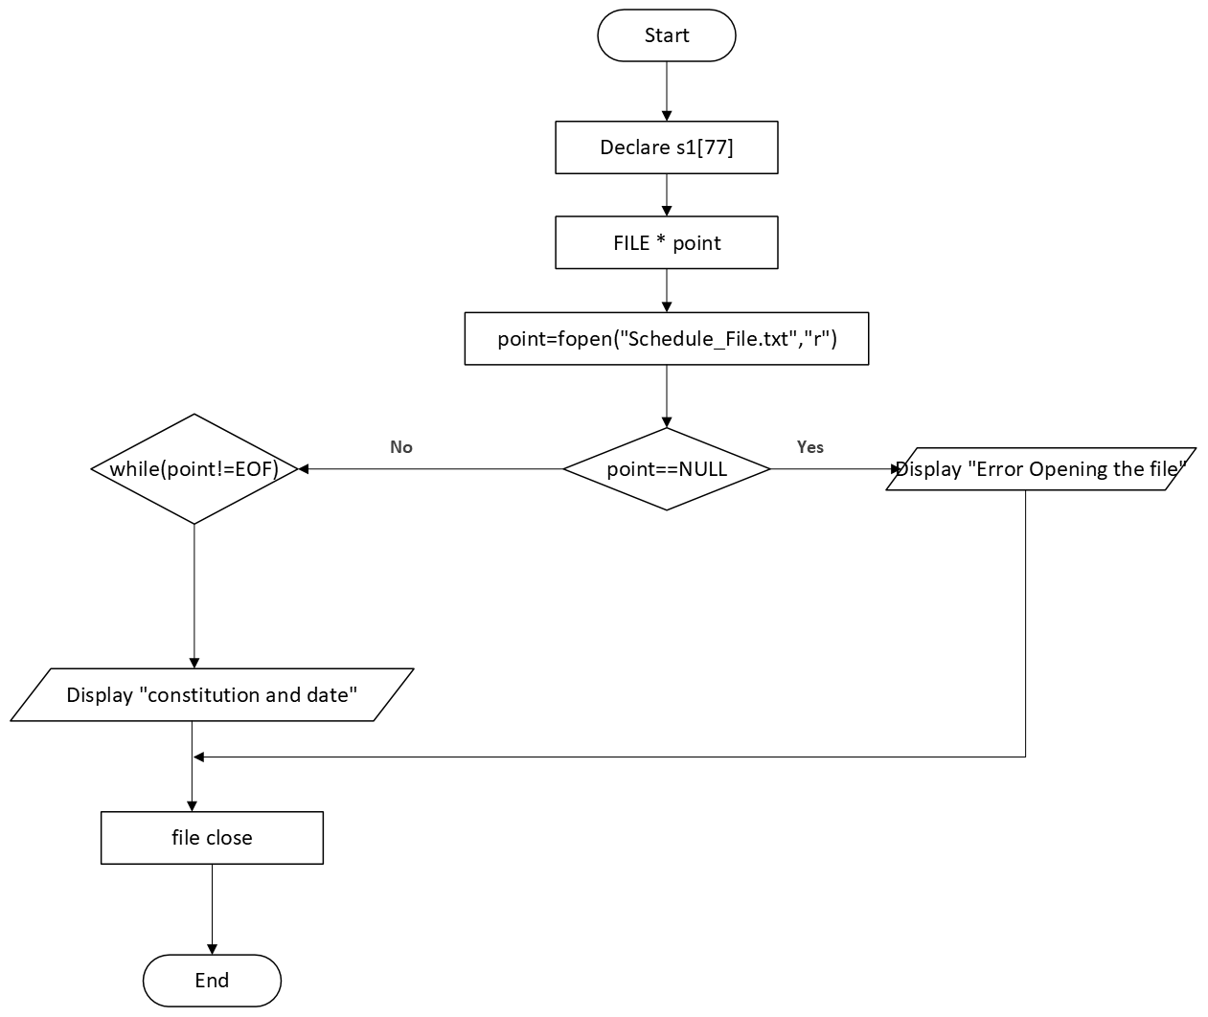

**Flowchart of candidate_reg**

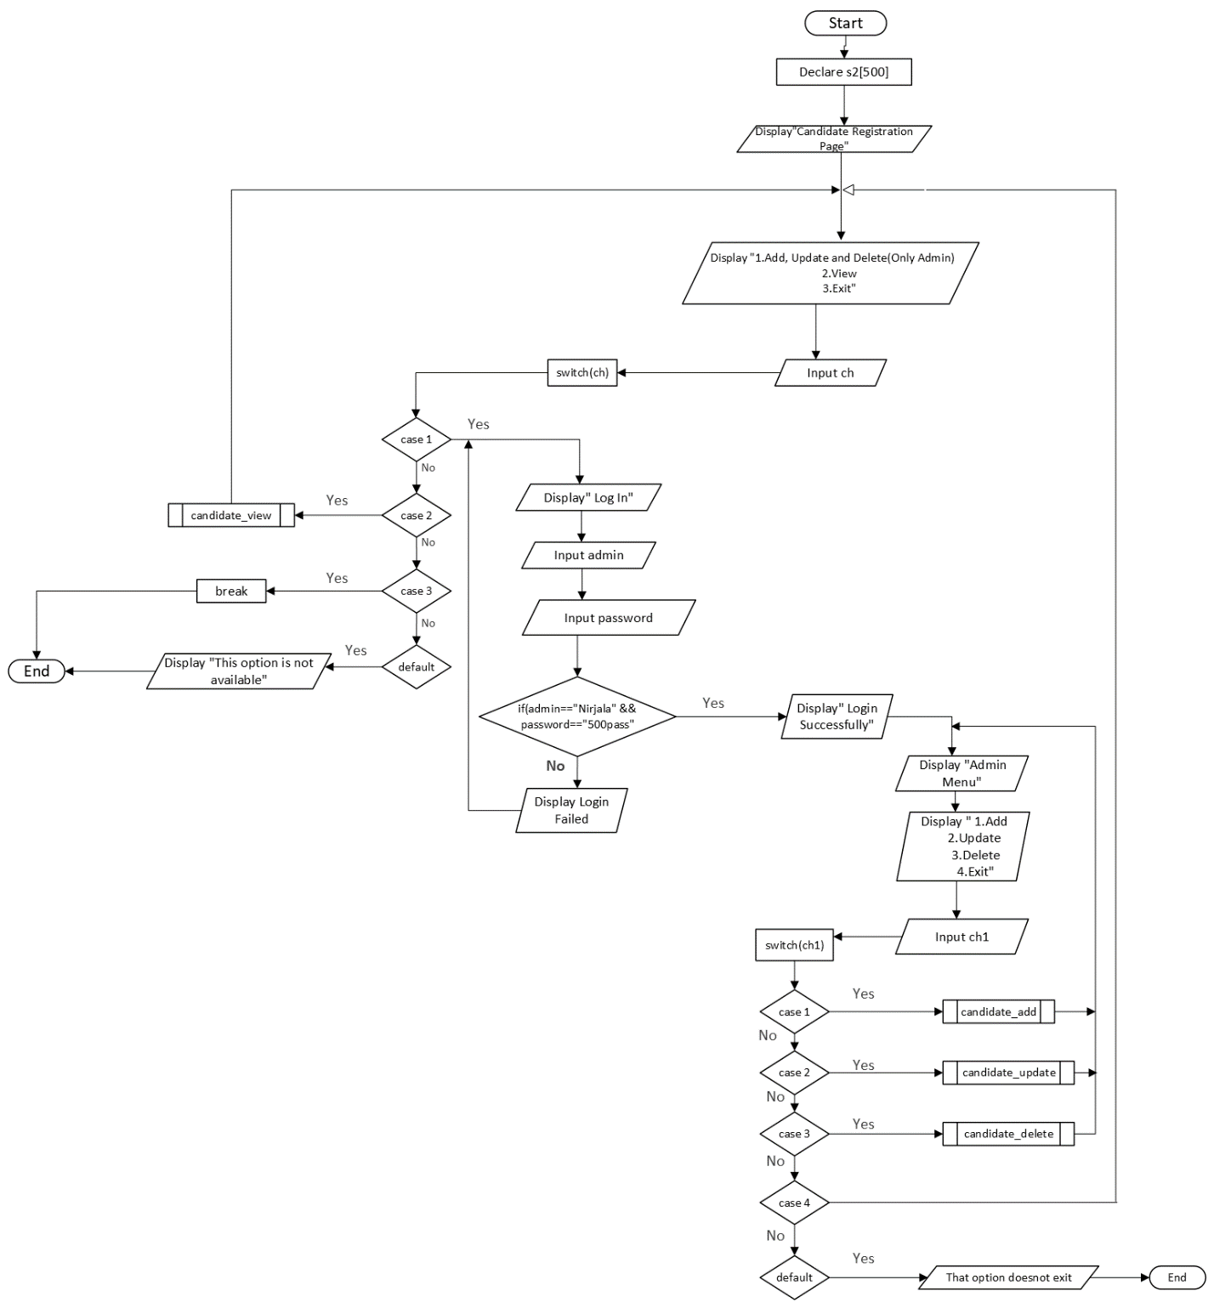

**Flowchart of candidate_add**

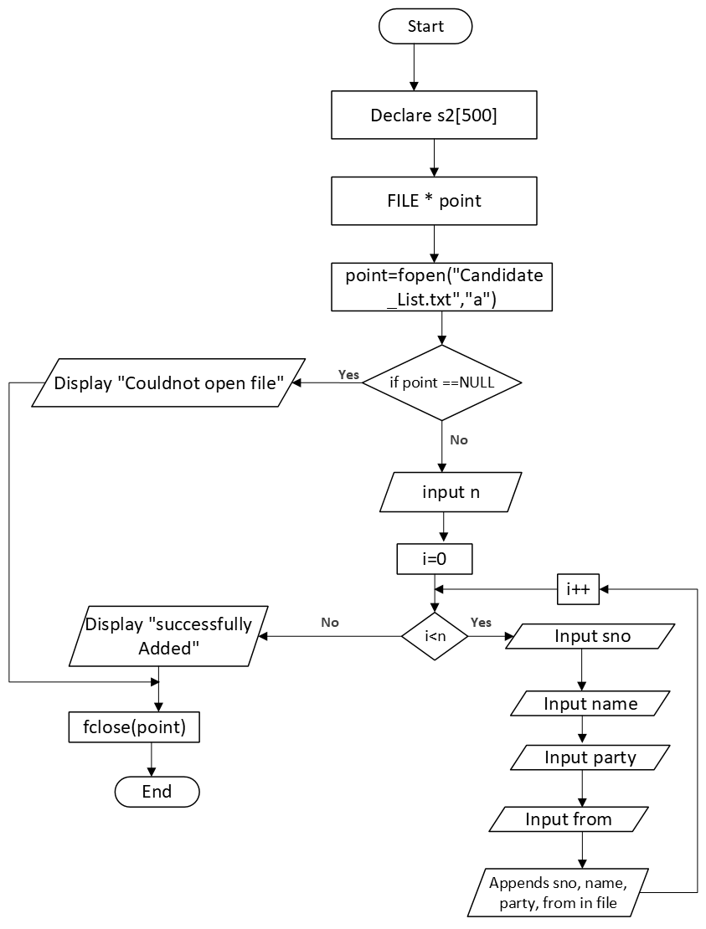

**Flowchart of candidate_update**

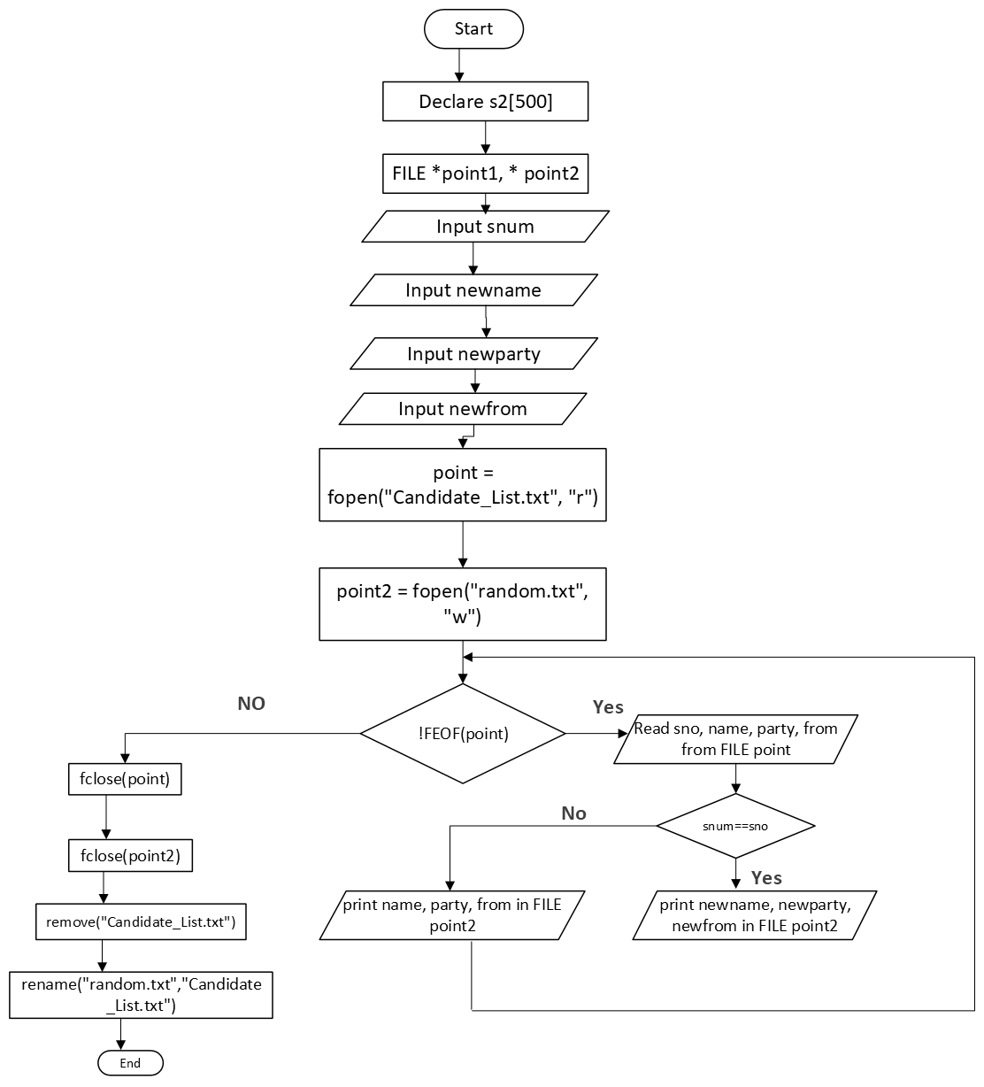

**Flowchart of candidate_delete()**

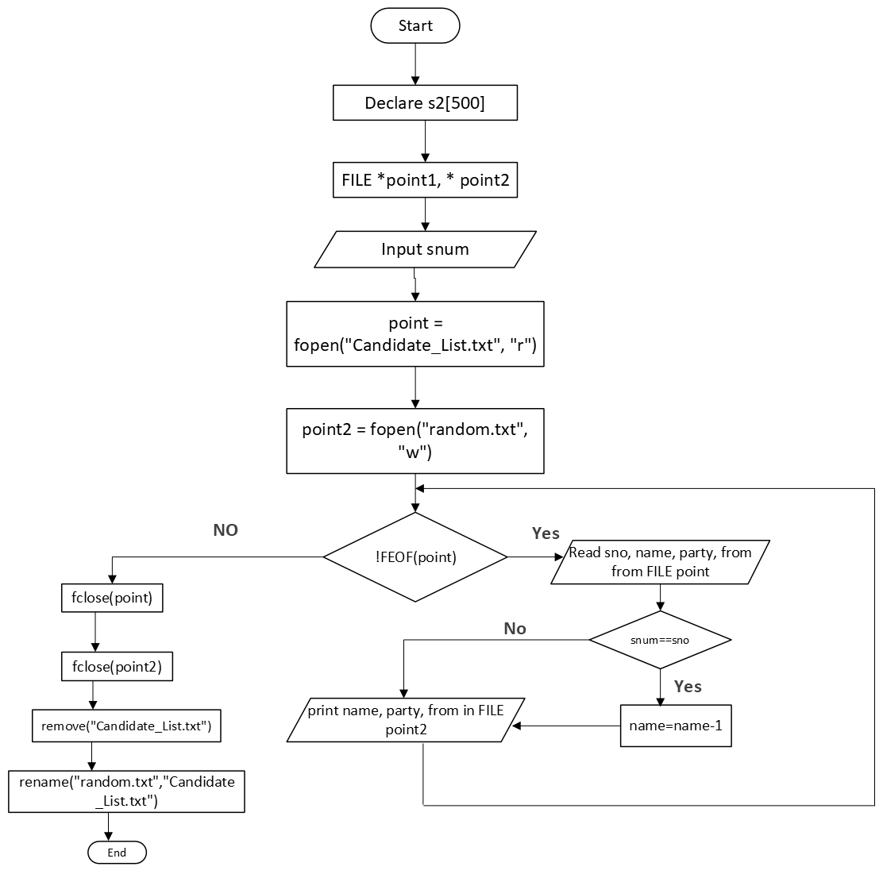

**Flowchart Of voter_reg()**

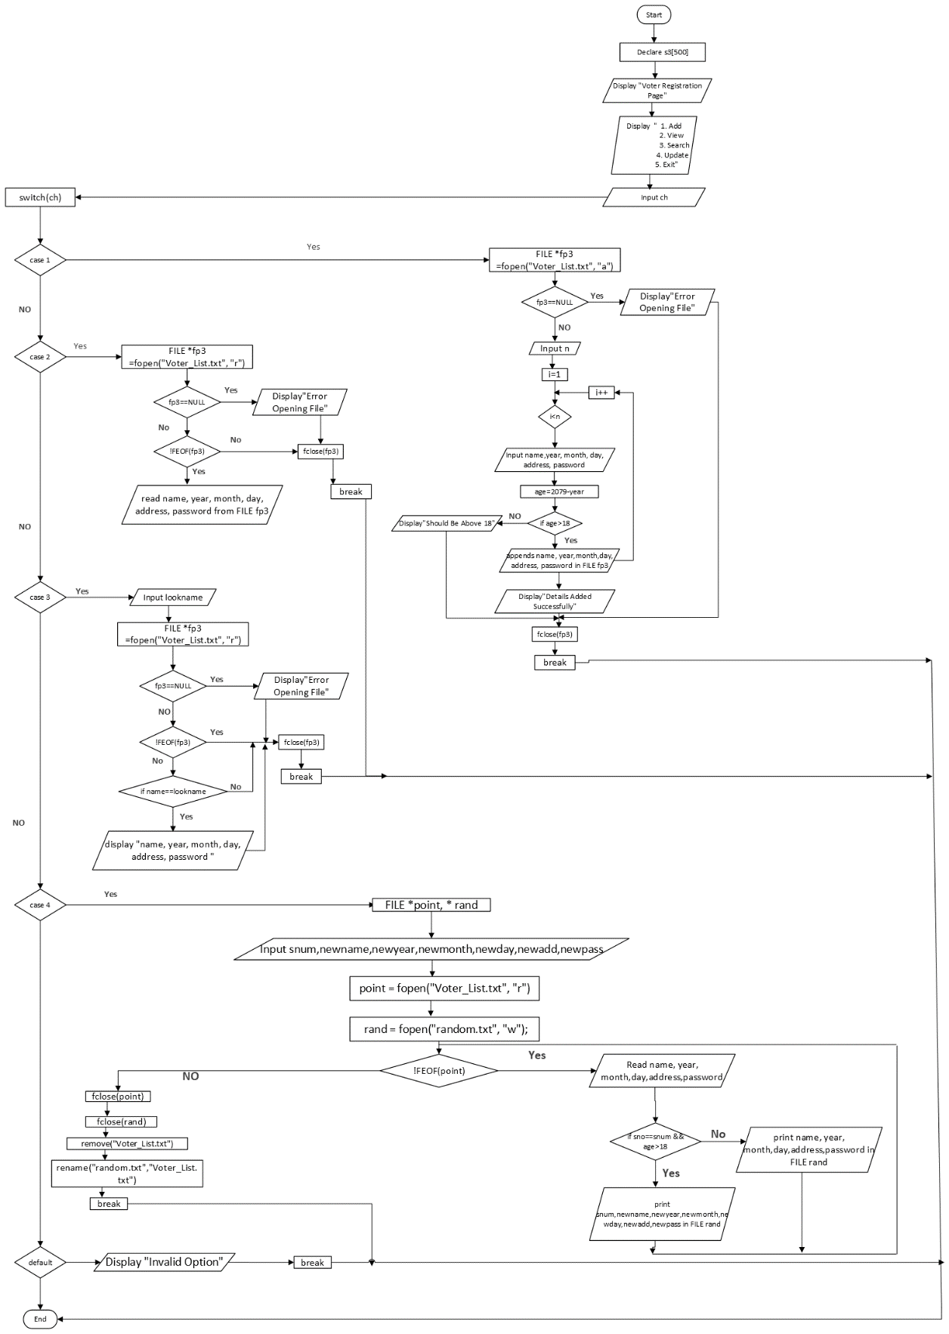

**Flowchart of vote_cast1()**

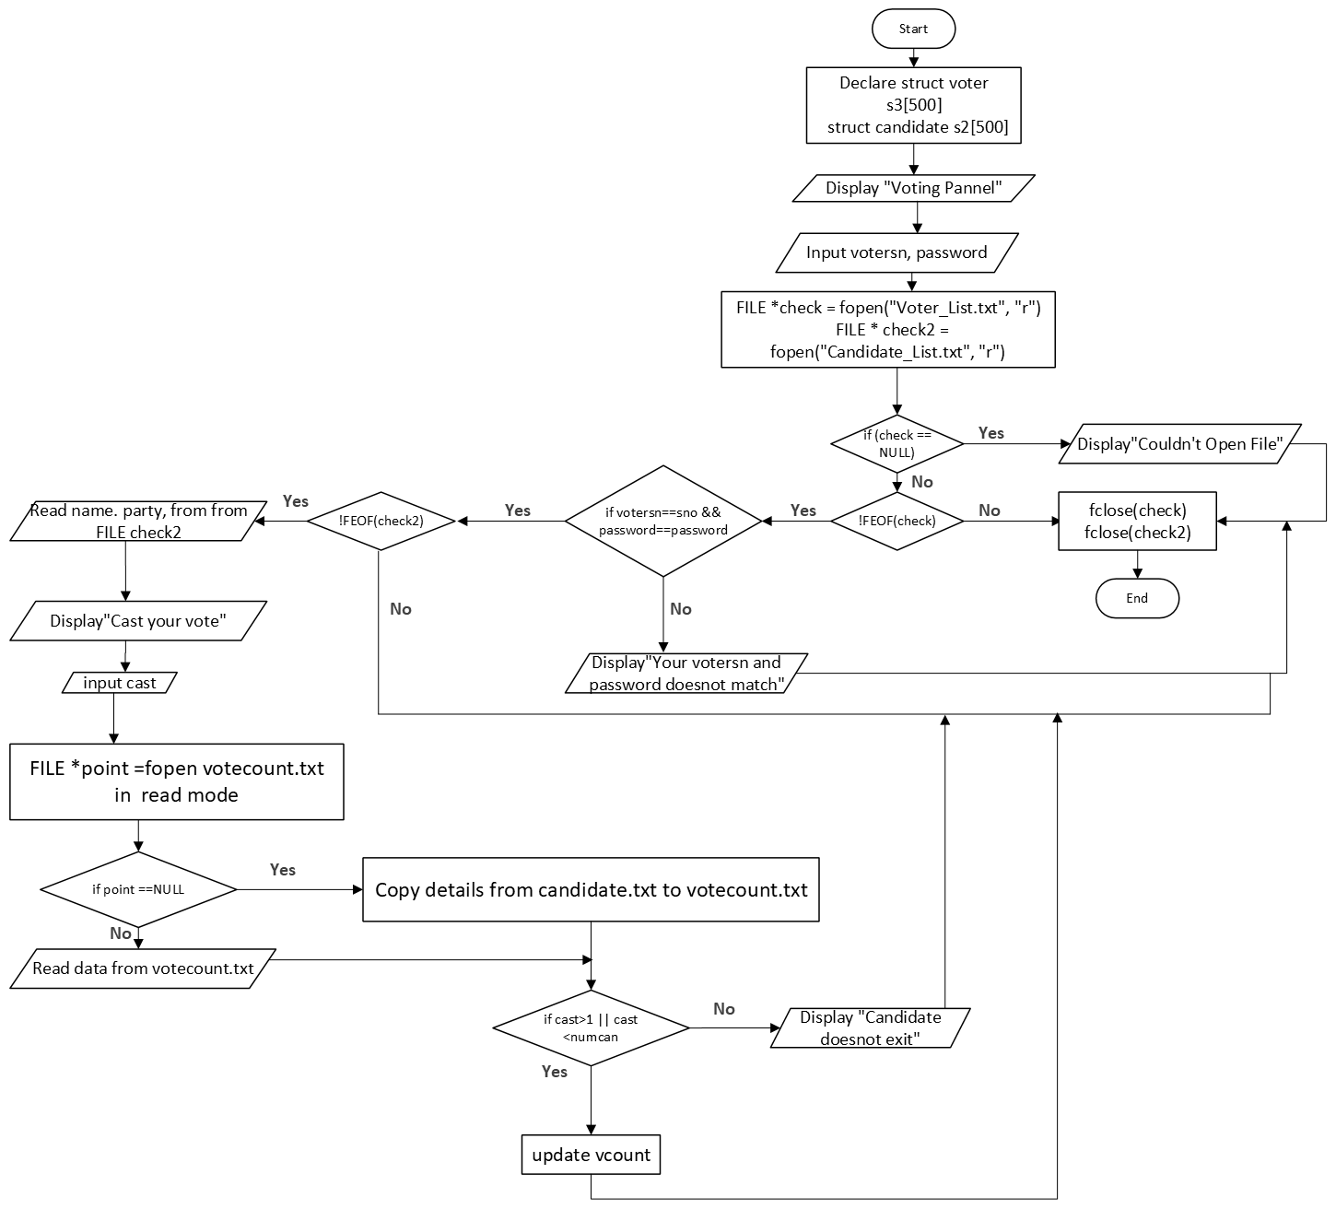

**Flowchart of final()**

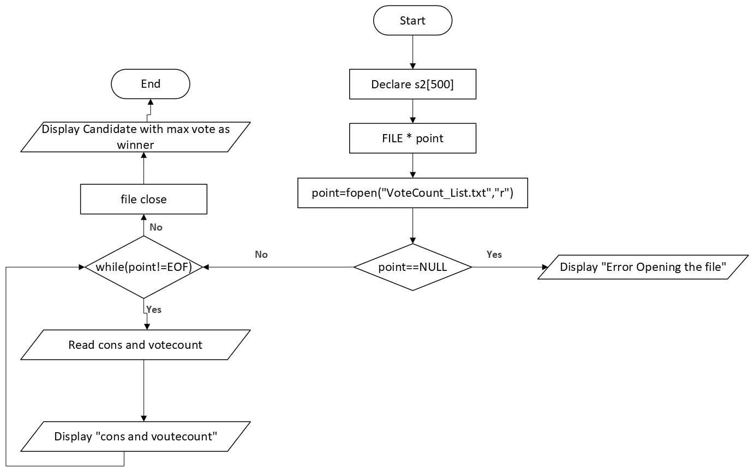

# 7. Source Code with Explanation

**Source Code 1**

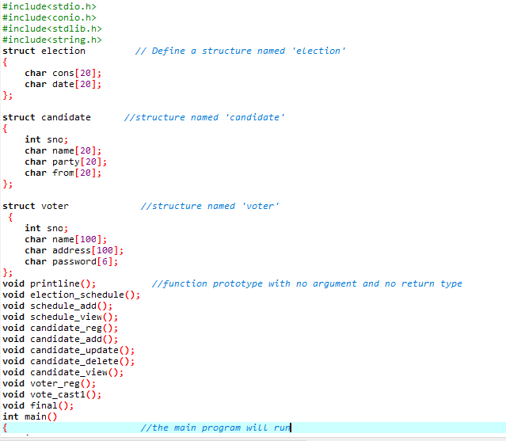

**Header Files**

C programming language has 25 standard header files that include functions and macros that can be used in C programs. Among these header files, "stdio.h" is commonly used for input and output functions like "printf()" and "scanf()".Another important header file is "string.h" that offers functions for manipulating strings, like "strlen()" and "strcpy()".The "conio.h" header file provides functions for performing console input and output operations like "clrscr()" to clear the screen and "getch()" to get input from the keyboard. The "stdlib.h" header file provides standard utility functions, including dynamic memory allocation using functions like "malloc()" and "calloc()" (Navneeth, 2022).

**Structure**

In the C programming language, it is possible to create variables of the structure type, and each of these variables is assigned a unique set of data members that belong to that particular structure. The code defines three C structures: "election", "candidate", and "voter", each with their own data members.

**Function**

The code declares several functions with different names and argument lists, such as "printline", "election_schedule", "schedule_add", "schedule_view", "candidate_reg", "candidate_add", "candidate_update", "candidate_delete", "candidate_view", "voter_reg", "vote_cast1", and "final". These functions have various purposes and actions, such as printing a line of text, managing an election schedule, registering candidates, updating or deleting candidate information, registering voters, casting votes, and displaying the final election results.

The function prototypes are declared before the main function, which is the entry point of the program. The main function returns an integer and has no parameters. It is the starting point of the program and it calls other functions to perform the desired tasks.

**Source Code 2**

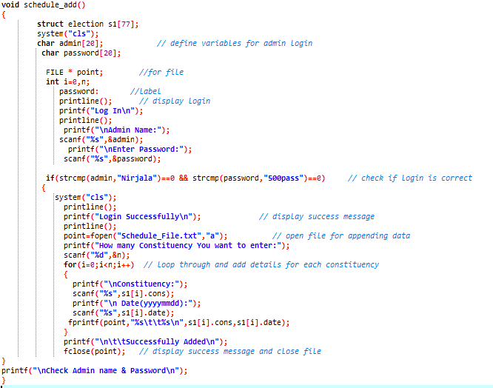

**C Variables**

In C, a variable is a storage location that holds a value of a specific data type. The value stored in the variable can be modified throughout the program execution. The declaration of a variable indicates the name that will be used to refer to it and the type of data that it can hold. In the C programming language, it is mandatory to specify and define all the variables that will be used in a program before they are utilized in the program's execution.

**Data Types**

C provides several data types, including basic types such as int, float, and char, as well as other data types like short, long, double, arrays, structures, and unions. Each data type has a specific range of values that it can store. In the above code, the variables "admin" and "password" are of the character data type, whereas "i" and "n" are of the integer data type. The "int", "char", and "FILE" data types are used throughout the entire program.

**Operators**

The values of variables can be assigned and manipulated using arithmetic and logical expressions. Arithmetic expressions include addition, subtraction, multiplication, and division. Logical expressions include AND, OR, and NOT operators.

As we can see, the above code uses a logical AND operator if(strcmp (admin,"Nirjala")==0 && strcmp(password,"500pass")==0) which will compare both admin and password value and if both is true then the program will continue and if one is false then it terminates.

**Strings**

Strings are used for storing text/characters (w3schools, n.d.).

This program uses the "strcmp" function to compare two strings and check if they are equal. The function returns an integer value based on the comparison, with 0 indicating that the strings are equal. If the first string is greater than the second, "strcmp" returns a positive integer, and if the first string is less than the second, it returns a negative integer. In this specific program, "strcmp" is utilized to check if the values entered by the user for the admin name and password match the expected values ("Nirjala" and "500pass", respectively) in an if statement.

**Array**

In C, arrays store multiple elements of the same data type in a contiguous block of memory, using an index that starts at 0 and goes up to n-1. Arrays provide a way to store and retrieve a collection of data elements using a single identifier, but all elements must be of the same data type (S, 2023).

In the above program, an array is used to store the details of multiple constituencies. The program first declares an array of structures named "s1" to hold the constituency details. A loop is then used to iterate through the array "s1" and add details for each constituency. Within the loop, the program prompts the user to enter the name and date of each constituency, which are then stored in the "cons" and "date" members of the current array element.The program uses array indexing to access the current element of the array in each iteration of the loop, as shown by the use of "s1[i]" to access the "cons" and "date" members.

**Source Code 3**

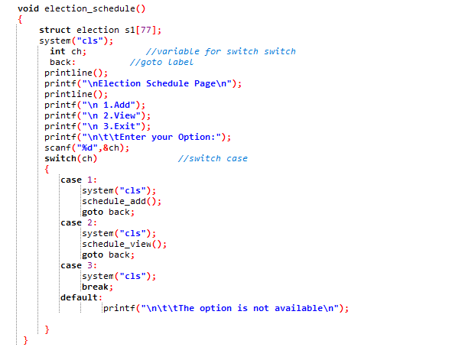

**Conditional Structure**

Commonly used conditional structure in this voting system are:

if-else statement: The program evaluates a conditional expression and if it is not equal to zero, which means it is TRUE, then it executes the subsequent statement. In the alternative case, where the conditional expression is equal to 0, which means it is FALSE, the program executes the statement after the "else" keyword (Bailey, 2005).

switch statement: It checks if an expression matches a constant integer value and executes the corresponding case label. The default label is executed if none of the case labels match. In above code, if case 1 is selected then it will clear the screen first then schedule_add() function will be called and the goto will be executed which transfer the control to the label declared as back.

**Source Code 4**

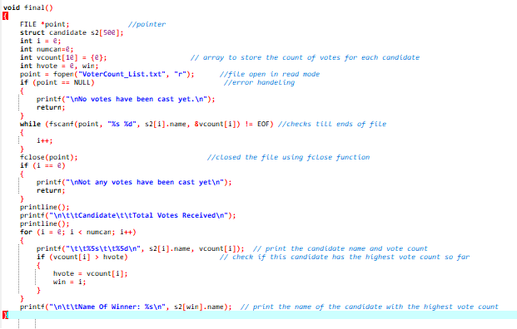

**Looping**

while loop: It executes the statement repeatedly as long as the expression is true. In the following code, it reads data from the file pointed to by "point" using the fscanf function until the end of the file is reached (EOF).

do..while loop: It executes the statement at least once, and then repeatedly as long as the expression is true.

for loop: It allows a variable to loop through a range of values and execute a block of statements for each value. This for (i = 0; i < numcan; i++) starts a loop that iterates over all candidates and prints their names and vote counts.

**File Handling**

fopen(): It is utilized to open a file that enables performing operations like writing or reading. It gives back a file pointer that can be utilized to perform additional operations on the file. While using fopen(), we declare a file pointer and specify the name of the file and the mode of operation. Like, point=fopen("VoterCount_List.txt","r") in the above source code.

fclose() : This function is employed to shut a file that is currently open with a file pointer. After closing the file, no further operations can be carried out on it.

fprintf(): This function is utilized to write a group of characters into a file. It sends an output in a formatted manner to a stream.

fscanf(): This function is employed to read a group of characters from a file. It reads a word from the file and returns an EOF (end-of-file) when it reaches the end of the file.

**Use of NULL**

NULL is a macro that is used to represent a null pointer, which is a pointer that does not point to any valid memory location. The use of NULL is a way to indicate that a pointer is not pointing to anything, which can be helpful in avoiding runtime errors such as segmentation faults or other undefined behavior.

# 8. Additional Feature

Once the voting process has been finalized and the results have been tabulated, any modifications made to a candidate's profile will not be taken into account in any future voting rounds. This helps to ensure the fairness and integrity of the voting process.

Similarly, an additional feature of the voting system is that enhances its user-friendliness. To elevate the aesthetic appeal of the user interface, I have implemented a "printline" function that is exclusively responsible for printing lines as and when needed. This function simplifies the design of the system and adds to its visual appeal, making it more attractive to users. The simplicity of this feature ensures that users can easily navigate the system and carry out their voting activities without any undue difficulties.

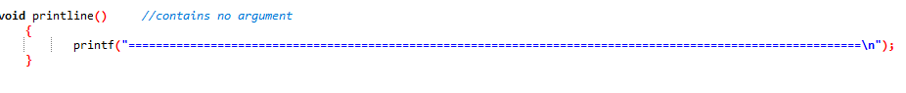

Figure: printline() function

# 9. Sample Output with Explanation

**Main Menu Page**

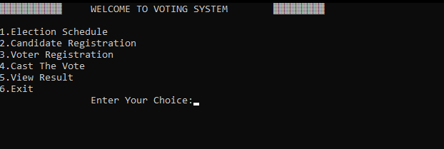

This is the primary interface of a voting system that displays a menu of six options to the user. The user can make a selection by inputting the corresponding number. If an incorrect option is selected, the program will perform a default action.

**Admin Log In**

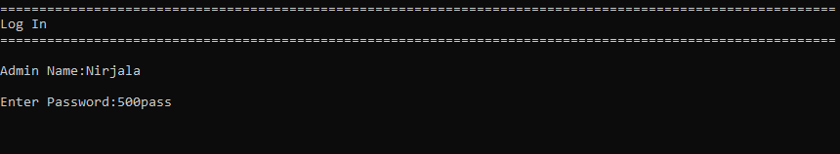

Access to certain special functions in the voting system, including adding, updating, and deleting data in the file, is restricted to the admin. The admin is required to provide the correct login credentials, which consist of a username and password. If the entered credentials are incorrect, an error message will be displayed to indicate that access is denied.

**Candidate List**

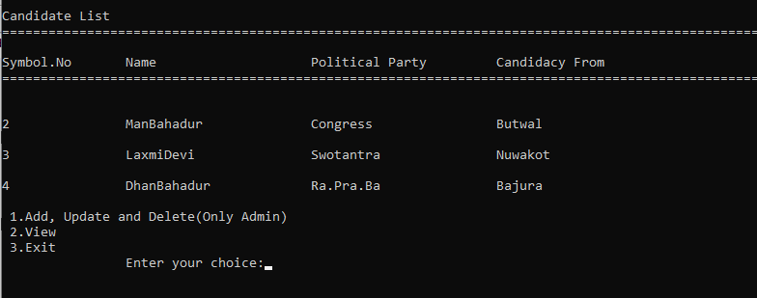

As previously explained, the candidate list provides the option to access the system's functionalities. Option 1 is specifically reserved for admin access, as only the admin can perform certain functions such as adding, updating, and deleting candidate information. In contrast, the view option is accessible to all users and allows them to view candidate information.

**Voter Registration Page**

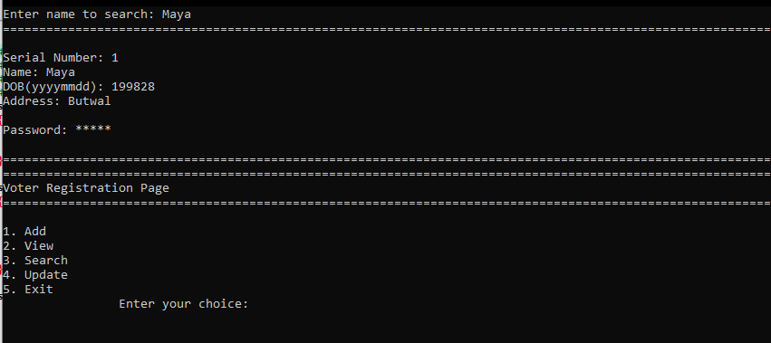

The provided sample displays an option 3 which enables the user to search for a particular voter by entering their name. Once the name is entered, the system automatically displays all the other relevant information about the voter. After executing the search function, the program returns to the main voter registration page. This allows the user to perform other tasks such as adding or updating voter information.

**Casting Vote Page**

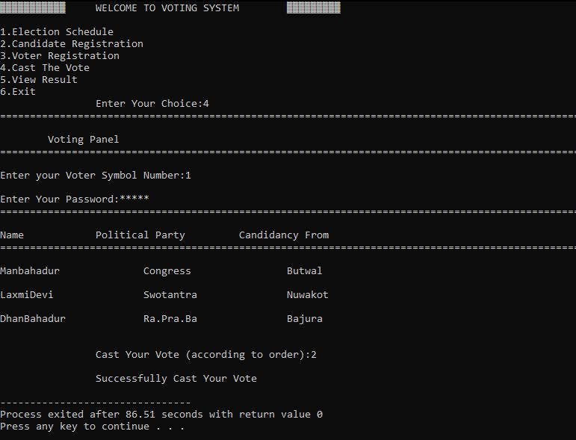

In the given illustration, if a user chooses option 4 to cast their vote, they are required to enter their unique symbol number and password to proceed. This prevents unauthorized access to the system and ensures that only eligible voters are able to cast their votes. Upon successful login, the names of the candidates are displayed, and the user can cast their vote based on the order of the candidates. Once the vote has been cast, the program terminates. It should be noted that any manipulation of candidate information after the vote has been cast will not affect the vote in any way.

**Result Page**

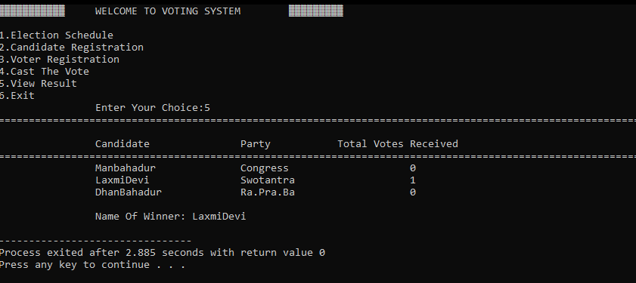

In addition to the options for casting votes, the system also provides the functionality to view the results of the voting process. This can be done by selecting the "View Results" option, which displays the candidate who has received the highest number of votes.

During the voting process, each candidate's initial vote count is set to zero. As users cast their votes, the system updates the candidate's vote count accordingly. Once all the votes have been cast, the candidate with the highest number of votes is declared the winner of the election.

# 10. Conclusion

In conclusion, this C-based voting system is a successful implementation of the requirements specified in the assignment. The system allows users to register, log in, vote for candidates, view election results, and schedule elections for different constituencies. The system also includes error handling mechanisms and constraints to ensure the integrity of the voting process.

Through this project, I have gained valuable experience in programming with C and developed my problem-solving skills. I have also learned the importance of clear and concise coding, documentation, and testing.

Overall, I am proud of the outcome of this project and believe that it can serve as a foundation for further development and improvement. With further learning and experience, I hope to continue to develop my programming skills and create more complex and sophisticated systems.

# References

Anthi Karatrantou, C. P. (2008). ASPAITE Patras. *Algorithm, Pseudo-Code and Lego Mindstorms*, 70-79.

Bailey, T. (2005). An Introduction to the C Programming Language. In T. Bailey, *An Introduction to the C Programming Language* (p. 17).

Brian W.Kernighan, D. M. (2002). The C Programming Language. 9. Retrieved 03 07, 2023

Navneeth. (2022, September 10). *List of Standard Header files in C*. Retrieved from OpenGenus IQ: Computing Expertise & Legacy: https://iq.opengenus.org/all-c-header-files/

S, R. A. (2023, Feb 13). *Array in C: Definition, Advantages, Declare, Initialize and More*. Retrieved from simplilearn: https://www.simplilearn.com/tutorials/c-tutorial/array-in-c

Technopedia. (2011, Aug 18). *What is Flowchart?* Retrieved from Techopedia: https://www.techopedia.com/definition/5512/flowchart

w3schools. (n.d.). *c_strings*. Retrieved 3 12, 2023, from w3schools: https://www.w3schools.com/c/c_strings.php

*fopen(), fclose(), gets(), fputs() functions in C | C File Handling*. (2020a, September 22). fresh2refresh.com. https://www.fresh2refresh.com/c-programming/c-file-handling/fopen-fclose-gets-fputs-functions-c/